SIMATS ENGINEERING
SAVEETHA INSTITUTE OF MEDICAL AND TECHNICAL SCIENCES
CHENNAI – 602105
Department of Computer Science and Engineering

ASSESSMENT TOOL 1 – DATA CLEANING CHALLENGE

Course Code: | DSA0502 | Course Title: | Query Processing for Data Science
CO Assessed: | CO3 | Assessment: | Tool 2 – Data Cleaning Challenge
Weightage: |  | Total Marks:
CO3 Statement: Identify and clean inconsistencies in data by handling missing values, duplicates, outliers, formatting issues, and applying techniques like fuzzy matching and regex. (BL5 and BL6).
Student Name: | G Rajasekhar Reddy | Reg. No.: | 192424216
Section / Batch: | BTech-AI&DS | Date of Submission: | 08/08/2026
Faculty In-charge: | Dr. B.Shyamala Gowri | Project Mode: | Individual Submission

Code of Conduct
I G. Rajasekhar Reddy (192424216) (Name / Reg No) certify that this submission is my original work and that I have adhered to all guidelines specified for this assessment. I understand that any violation of academic integrity rules will result in disciplinary action.
Signature: G Rajasekhar Reddy

Anomaly Detection  (5 Marks) | Cleaning Methods  (5 Marks) | Data Transformation  (5 Marks) | Analytical Comparison  (5 Marks) | Governance Discussion  (5 Marks) | Total (25 Marks)

Question 1: E-Commerce Customer Transactions Dataset

An online retail company has collected customer transaction data from multiple sales channels. The management wants to identify the top-performing customer segments and products. However, the dataset contains several quality issues.

CustomerID | CustomerName | Gender | Age | ProductCategory | Quantity | UnitPrice | PurchaseDate | City
C101 | Raj Kumar | Male | 28 | Electronics | 2 | 15000 INR | 10-01-2025 | Chennai
C102 | Priya S | Female | 35 | Fashion | 3 | 1200 INR | 11-01-2025 | chennai
C103 | Arun V | Male | 150 | Electronics | 1 | 300 USD | 12-01-2025 | CHENNAI
C104 | Kavya R | Female | 0 | Grocery | -2 | 800 INR | 15-01-2025 | Coimbatore
C105 | Rahul P | Male | 42 | Fashion | 5 | 2500 INR | 18-01-2025 | Madurai
C105 | Rahul P | Male | 42 | Fashion | 5 | 2500 INR | 18-01-2025 | Madurai
NULL | Sneha M | Female | 30 | Electronics | 2 | 450 USD | 05-02-2025 | Trichy
C107 | Deepak N | Male |  | Grocery | 3 | 600 INR | 07-02-2025 | Tiruchirappalli
C108 | Meena K | Female | 27 | Fashion | 1 | 1800 INR | 2025-13-01 | Salem
C109 | John D | Male | 31 | Electronics | 4 | 250 EUR | 15-02-2025 | Chennai

Data Issues
- Missing Customer IDs
- Duplicate transactions
- Negative quantities
- Unit prices recorded in different currencies
- Age values such as 0, 150, and blanks
- Inconsistent city names (e.g., Chennai, chennai, CHENNAI)
- Incorrect purchase dates

Tasks
- Identify and classify all data quality issues. (5 Marks)
- Design a cleaning strategy for each issue. (5 Marks)
- Perform data standardization and transformation. (5 Marks)
- Analyze how cleaning affects total revenue calculations. (5 Marks)
- Generate a report discussing business risks if the data were not cleaned. (5 Marks)

Aim:
To identify, clean, standardize, and transform inconsistencies in an e-commerce customer transaction dataset by handling missing values, duplicate transactions, negative quantities, different currencies, invalid ages, inconsistent city names, and incorrect purchase dates, and to analyze the effect of data cleaning on total revenue.
Program:
import pandas as pd
import numpy as np
# ---------------------------------------------------------
# 1. CREATE THE E-COMMERCE CUSTOMER TRANSACTION DATASET
# ---------------------------------------------------------
data = {
"CustomerID": [
"C101", "C102", "C103", "C104", "C105",
"C105", None, "C107", "C108", "C109"
],
"CustomerName": [
"Raj Kumar", "Priya S", "Arun V", "Kavya R", "Rahul P",
"Rahul P", "Sneha M", "Deepak N", "Meena K", "John D"
],
"Gender": [
"Male", "Female", "Male", "Female", "Male",
"Male", "Female", "Male", "Female", "Male"
],
"Age": [
28, 35, 150, 0, 42,
42, 30, None, 27, 31
],
"ProductCategory": [
"Electronics", "Fashion", "Electronics", "Grocery", "Fashion",
"Fashion", "Electronics", "Grocery", "Fashion", "Electronics"
],
"Quantity": [
2, 3, 1, -2, 5,
5, 2, 3, 1, 4
],
"UnitPrice": [
15000, 1200, 300, 800, 2500,
2500, 450, 600, 1800, 250
],
"Currency": [
"INR", "INR", "USD", "INR", "INR",
"INR", "USD", "INR", "INR", "EUR"
],
"PurchaseDate": [
"10-01-2025",
"11-01-2025",
"12-01-2025",
"15-01-2025",
"18-01-2025",
"18-01-2025",
"05-02-2025",
"07-02-2025",
"2025-13-01",
"15-02-2025"
],
"City": [
"Chennai", "chennai", "CHENNAI", "Coimbatore",
"Madurai", "Madurai", "Trichy",
"Tiruchirappalli", "Salem", "Chennai"
]
}
df = pd.DataFrame(data)
print("========== ORIGINAL DATASET ==========")
print(df)
print()
# =========================================================
# TASK 1: IDENTIFY AND CLASSIFY DATA QUALITY ISSUES
# =========================================================
print("========== TASK 1 ==========")
print("IDENTIFY AND CLASSIFY DATA QUALITY ISSUES")
print()
# Missing Customer IDs
print("1. Missing Customer IDs:")
print(df[df["CustomerID"].isnull()])
print()
# Duplicate transactions
print("2. Duplicate Transactions:")
print(df[df.duplicated(keep=False)])
print()
# Negative quantities
print("3. Negative Quantities:")
print(df[df["Quantity"] < 0])
print()
# Invalid ages
print("4. Invalid Ages:")
print(df[(df["Age"] <= 0) | (df["Age"] > 120)])
print()
# Missing ages
print("5. Missing Ages:")
print(df[df["Age"].isnull()])
print()
# Different currencies
print("6. Different Currencies:")
print(df["Currency"].unique())
print()
# Inconsistent cities
print("7. City Names:")
print(df["City"].unique())
print()

# Invalid dates
date_check = pd.to_datetime(
df["PurchaseDate"],
dayfirst=True,
errors="coerce"
)
print("8. Invalid Purchase Dates:")
print(df[date_check.isnull()][
["CustomerID", "PurchaseDate"]
])
print()
# =========================================================
# TASK 2: DESIGN CLEANING STRATEGY
# =========================================================
print("========== TASK 2 ==========")
print("CLEANING STRATEGY")
print()
print("Missing Customer ID -> Assign a temporary Customer ID")
print("Duplicate transaction -> Remove duplicate record")
print("Negative quantity -> Remove invalid transaction")
print("Invalid age -> Convert to missing value")
print("Missing age -> Replace using median age")
print("Different currencies -> Convert all values to INR")
print("City inconsistency -> Standardize city names")
print("Invalid date -> Convert to NULL")
print()
# =========================================================
# TASK 3: DATA STANDARDIZATION AND TRANSFORMATION
# =========================================================
print("========== TASK 3 ==========")
print("DATA STANDARDIZATION AND TRANSFORMATION")
print()
clean_df = df.copy()
# ---------------------------------------------------------
# Handle missing Customer ID
# ---------------------------------------------------------
clean_df["CustomerID"] = clean_df["CustomerID"].fillna("C106")
# ---------------------------------------------------------
# Remove duplicate transactions
# ---------------------------------------------------------
clean_df = clean_df.drop_duplicates()
# ---------------------------------------------------------
# Remove negative quantities
# ---------------------------------------------------------
clean_df = clean_df[
clean_df["Quantity"] >= 0
].copy()
# ---------------------------------------------------------
# Handle invalid ages
# ---------------------------------------------------------
clean_df.loc[
(clean_df["Age"] <= 0) |
(clean_df["Age"] > 120),
"Age"
] = np.nan
# Fill missing age using median
clean_df["Age"] = clean_df["Age"].fillna(
clean_df["Age"].median()
)
# ---------------------------------------------------------
# Standardize city names
# ---------------------------------------------------------
clean_df["City"] = (
clean_df["City"]
.str.strip()
.str.title()
)
# ---------------------------------------------------------
# Standardize purchase dates
# ---------------------------------------------------------
clean_df["PurchaseDate"] = pd.to_datetime(
clean_df["PurchaseDate"],
dayfirst=True,
errors="coerce"
)
# ---------------------------------------------------------
# Currency conversion
# Rates are assumptions because the question does
# not provide exchange rates.
# ---------------------------------------------------------
exchange_rates = {
"INR": 1,
"USD": 85,
"EUR": 90
}
# Create revenue column
clean_df["Revenue_INR"] = (
clean_df["Quantity"]
* clean_df["UnitPrice"]
* clean_df["Currency"].map(exchange_rates)
)
print("Missing Customer ID handled")
print("Duplicate transaction removed")
print("Negative quantity removed")
print("Invalid and missing ages handled")
print("City names standardized")
print("Purchase dates standardized")
print("Currencies converted to INR")
print()

print("========== CLEANED DATASET ==========")
print(clean_df)
print()
# =========================================================
# TASK 4: ANALYZE EFFECT ON TOTAL REVENUE
# =========================================================
print("========== TASK 4 ==========")
print("REVENUE BEFORE AND AFTER CLEANING")
print()
# Revenue before cleaning
original_df = df.copy()
original_df["Revenue_INR"] = (
original_df["Quantity"]
* original_df["UnitPrice"]
* original_df["Currency"].map(exchange_rates)
)
revenue_before = original_df["Revenue_INR"].sum()
# Revenue after cleaning
revenue_after = clean_df["Revenue_INR"].sum()
print("Total Revenue BEFORE cleaning:")
print("INR", round(revenue_before, 2))
print()
print("Total Revenue AFTER cleaning:")
print("INR", round(revenue_after, 2))
print()
print("Difference in Revenue:")
print(
"INR",
round(revenue_before - revenue_after, 2)
)
print()
# =========================================================
# TASK 5: BUSINESS RISKS IF DATA IS NOT CLEANED
# =========================================================
print("========== TASK 5 ==========")
print("BUSINESS RISKS")
print()
print("1. Incorrect total revenue calculation")
print("2. Duplicate transactions can cause double counting")
print("3. Missing Customer IDs can affect customer analysis")
print("4. Invalid quantities can produce incorrect revenue")
print("5. Inconsistent city names can affect regional analysis")
print("6. Incorrect dates can affect sales trends")
print("7. Wrong data can lead to poor business decisions")
Output:
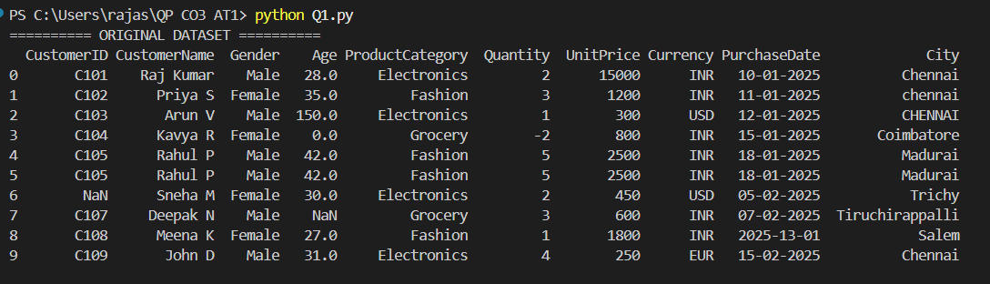
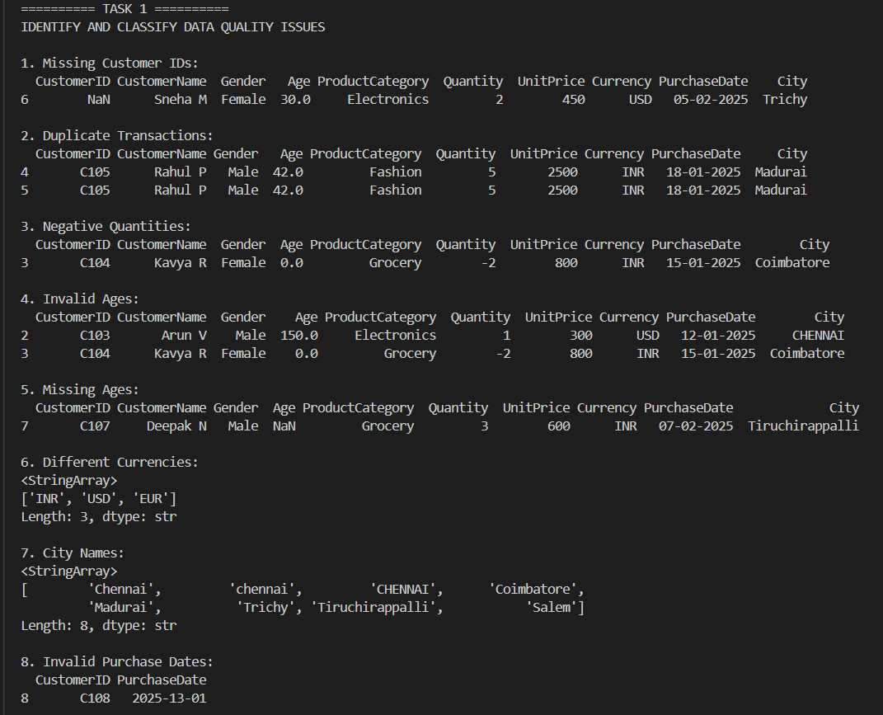
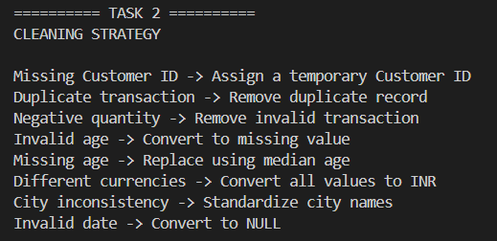
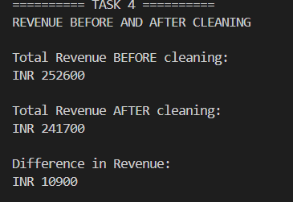

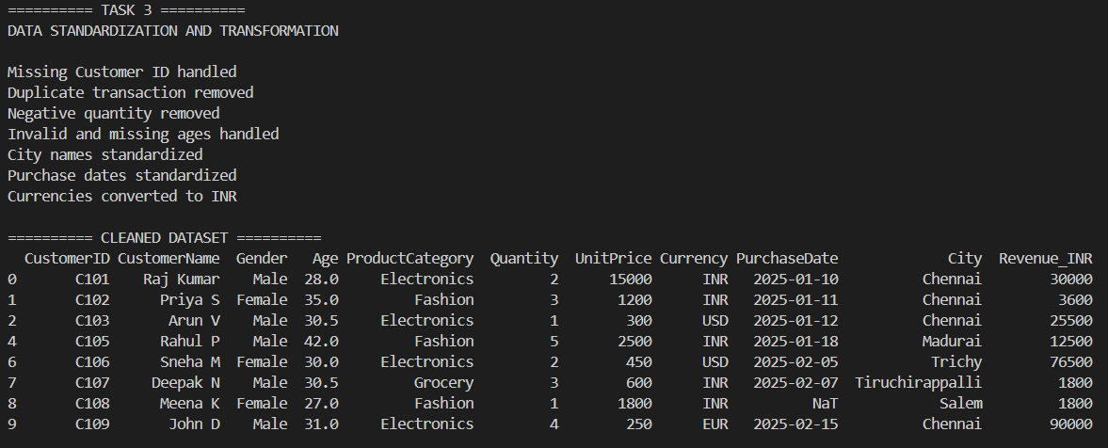
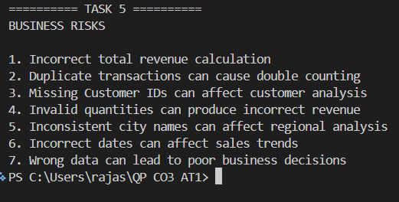

Question 4: Smart City Traffic Monitoring Dataset

A smart city project collects traffic sensor data to optimize traffic signals. Sensor malfunctions and transmission errors have affected data quality.

SensorID | Timestamp | VehicleCount | AverageSpeed | TrafficSignalStatus | RoadName | WeatherCondition
S101 | 01-01-2025 08:00 | 120 | 45 | Green | Anna Salai | Sunny
S102 | 01-01-2025 08:05 | 135 | 52 | Red | anna salai | Sunny
S103 | 01-01-2025 08:10 | -50 | 48 | Green | ANNA SALAI | Cloudy
S104 | 01-01-2025 08:15 | 140 | 350 | Yellow | GST Road | Rainy
S105 | NULL | 110 | 42 | Green | GST ROAD | Sunny
S106 | 01-01-2025 08:25 | 130 | 46 | Red | OMR | NULL
S106 | 01-01-2025 08:25 | 130 | 46 | Red | OMR | NULL
S107 | 01-01-2025 08:30 | 150 | 55 | Green | Old Mahabalipuram Road | Sunny
S10A | 01-01-2025 08:35 | 145 | 53 | Green | OMR | Cloudy
S109 | 01-01-2025 08:40 | 138 | 50 | Green | GST Road | Rainy

Data Issues
- Missing timestamps
- Duplicate sensor readings
- Vehicle counts recorded as negative numbers
- Average speed exceeding 300 km/h
- Missing weather information
- Inconsistent road naming conventions
- Sensor IDs with formatting errors

Tasks
- Assess the quality of the traffic dataset. (5 Marks)
- Recommend cleaning techniques for time-series data. (5 Marks)
- Design rules to identify faulty sensor readings. (5 Marks)
- Evaluate how cleaning affects congestion analysis. (5 Marks)
- Suggest automated monitoring techniques for future data collection. (5 Marks)

Aim:
To assess and clean the smart city traffic monitoring dataset by identifying missing timestamps, duplicate sensor readings, negative vehicle counts, abnormal speed values, missing weather information, inconsistent road names, and sensor ID formatting errors, and to evaluate how data cleaning affects congestion analysis.

Program:
import pandas as pd
import numpy as np
# ---------------------------------------------------------
# 1. CREATE THE SMART CITY TRAFFIC DATASET
# ---------------------------------------------------------
data = {
"SensorID": [
"S101", "S102", "S103", "S104", "S105",
"S106", "S106", "S107", "S10A", "S109"
],
"Timestamp": [
"01-01-2025 08:00",
"01-01-2025 08:05",
"01-01-2025 08:10",
"01-01-2025 08:15",
None,
"01-01-2025 08:25",
"01-01-2025 08:25",
"01-01-2025 08:30",
"01-01-2025 08:35",
"01-01-2025 08:40"
],
"VehicleCount": [
120, 135, -50, 140, 110,
130, 130, 150, 145, 138
],
"AverageSpeed": [
45, 52, 48, 350, 42,
46, 46, 55, 53, 50
],
"TrafficSignalStatus": [
"Green", "Red", "Green", "Yellow", "Green",
"Red", "Red", "Green", "Green", "Green"
],
"RoadName": [
"Anna Salai",
"anna salai",
"ANNA SALAI",
"GST Road",
"GST ROAD",
"OMR",
"OMR",
"Old Mahabalipuram Road",
"OMR",
"GST Road"
],
"WeatherCondition": [
"Sunny", "Sunny", "Cloudy", "Rainy", "Sunny",
None, None, "Sunny", "Cloudy", "Rainy"
]
}
df = pd.DataFrame(data)
print("========== ORIGINAL DATASET ==========")
print(df)
print()
# =========================================================
# TASK 1: ASSESS THE QUALITY OF THE TRAFFIC DATASET
# =========================================================
print("========== TASK 1 ==========")
print("DATA QUALITY ISSUES")
print()
# Missing timestamps
print("1. Missing Timestamps:")
print(df[df["Timestamp"].isnull()])
print()
# Duplicate readings
print("2. Duplicate Sensor Readings:")
print(df[df.duplicated(keep=False)])
print()
# Negative vehicle counts
print("3. Negative Vehicle Counts:")
print(df[df["VehicleCount"] < 0])
print()
# Abnormal speed
print("4. Abnormal Speed (>300 km/h):")
print(df[df["AverageSpeed"] > 300])
print()
# Missing weather
print("5. Missing Weather Information:")
print(df[df["WeatherCondition"].isnull()])
print()
# Inconsistent road names
print("6. Road Names:")
print(df["RoadName"].unique())
print()
# Sensor ID formatting issue
print("7. Sensor ID Formatting Issue:")
print(df[df["SensorID"] == "S10A"])
print()
# =========================================================
# TASK 2: CLEANING TECHNIQUES FOR TIME-SERIES DATA
# =========================================================

print("========== TASK 2 ==========")
print("CLEANING THE TIME-SERIES DATA")
print()
clean_df = df.copy()
# Convert timestamp into datetime format
clean_df["Timestamp"] = pd.to_datetime(
clean_df["Timestamp"],
dayfirst=True,
errors="coerce"
)
# Fill missing timestamp using time interpolation
clean_df["Timestamp"] = clean_df["Timestamp"].interpolate()
print("Missing timestamp handled")
print()
# Remove duplicate sensor readings
clean_df = clean_df.drop_duplicates()
print("Duplicate sensor reading removed")
print()
# Negative vehicle count is invalid
clean_df.loc[
clean_df["VehicleCount"] < 0,
"VehicleCount"
] = np.nan
print("Negative vehicle count changed to NULL")
print()
# Abnormal speed is removed
clean_df = clean_df[
clean_df["AverageSpeed"] <= 300
].copy()
print("Abnormal speed above 300 km/h removed")
print()
# Handle missing weather
clean_df["WeatherCondition"] = (
clean_df["WeatherCondition"].fillna("Unknown")
)
print("Missing weather changed to Unknown")
print()
# Standardize road names
clean_df["RoadName"] = (
clean_df["RoadName"]
.str.strip()
.str.title()
)
print("Road names standardized")
print()
# =========================================================
# TASK 3: RULES TO IDENTIFY FAULTY SENSOR READINGS
# =========================================================
print("========== TASK 3 ==========")
print("FAULTY SENSOR RULES")
print()
print("Rule 1: Vehicle count < 0 -> Faulty reading")
print("Rule 2: Average speed > 300 km/h -> Faulty reading")
print("Rule 3: Missing timestamp -> Flag for checking")
print("Rule 4: Same SensorID and Timestamp -> Duplicate reading")
print("Rule 5: Invalid sensor ID format -> Flag for checking")
print()
# Check faulty vehicle counts
faulty_vehicle = df[df["VehicleCount"] < 0]
print("Faulty Vehicle Count Records:")
print(faulty_vehicle)
print()
# Check abnormal speeds
faulty_speed = df[df["AverageSpeed"] > 300]
print("Faulty Speed Records:")
print(faulty_speed)
print()
# =========================================================
# TASK 4: EFFECT OF CLEANING ON CONGESTION ANALYSIS
# =========================================================
print("========== TASK 4 ==========")
print("CONGESTION ANALYSIS")
print()
# Average speed before cleaning
average_speed_before = df["AverageSpeed"].mean()
# Average speed after cleaning
average_speed_after = clean_df["AverageSpeed"].mean()
print("Average Speed BEFORE cleaning:")
print(round(average_speed_before, 2), "km/h")
print()
print("Average Speed AFTER cleaning:")
print(round(average_speed_after, 2), "km/h")
print()
print("Change in Average Speed:")
print(
round(
average_speed_before - average_speed_after,
2
),
"km/h"
)
print()
# =========================================================
# TASK 5: AUTOMATED MONITORING TECHNIQUES
# =========================================================
print("========== TASK 5 ==========")
print("AUTOMATED MONITORING TECHNIQUES")
print()
print("1. Range validation for vehicle count and speed")
print("2. Automatic duplicate detection")
print("3. Timestamp validation")
print("4. Sensor ID format validation")
print("5. Automatic missing-value alerts")
print("6. Real-time sensor monitoring dashboard")
print()
# =========================================================
# FINAL CLEANED DATASET
# =========================================================
print("========== CLEANED DATASET ==========")
print(clean_df)

Output:
